**Practical Documentation ☺**

***~By:- Dev Bhatia***

# Practical Number : 21

# Practical Name :

To calculate Positive , Negative ,Odd and Even numbers in given data

**Code:**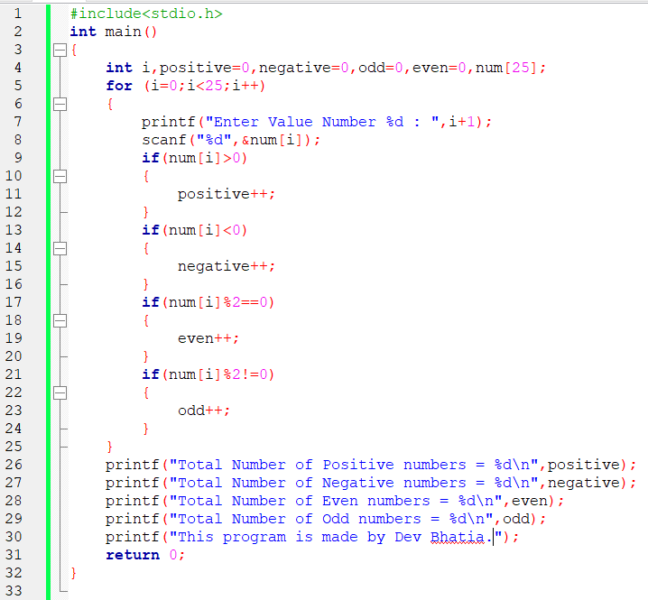

# Output

Output screenshot is below:

